**Capstone Project – The Battle of Neighborhoods**

Discovering Top Venues in Scarborough, Toronto, Ontario, Canada

Introduction:

Scarborough is an administrative division in [Toronto](https://en.wikipedia.org/wiki/Toronto), [Ontario](https://en.wikipedia.org/wiki/Ontario), Canada. Situated atop the [Scarborough Bluffs](https://en.wikipedia.org/wiki/Scarborough_Bluffs), it occupies the eastern part of the city. As of the 2011 Census, it had a population of 625, 698. Scarborough is contained within the borders of [Victoria Park Avenue](https://en.wikipedia.org/wiki/Victoria_Park_Avenue) on the west, [Steeles Avenue](https://en.wikipedia.org/wiki/Steeles_Avenue_(Toronto)) to the north, [Rouge River](https://en.wikipedia.org/wiki/Rouge_River_(Ontario)) and the city of [Pickering](https://en.wikipedia.org/wiki/Pickering,_Ontario) to the east, and [Lake Ontario](https://en.wikipedia.org/wiki/Lake_Ontario) to the south. It borders [Old Toronto](https://en.wikipedia.org/wiki/Old_Toronto), [East York](https://en.wikipedia.org/wiki/East_York) and [North York](https://en.wikipedia.org/wiki/North_York) in the west and the city of [Markham](https://en.wikipedia.org/wiki/Markham,_Ontario) in the north. The neighbourhood of Scarborough has various sights for visitors thanks to its population of high diversity and different cultures, making it a good place for people to hang out.

This project is aimed at recommending places to chill out (entertainment, accommodation, restaurant, etc.) for people visiting the neighborhood of Scarborough. The recommendation system is built on Foursquare dataset, geographical data, and venue information of Scarborough from the internet.

Data Overview:

The datasets used in this project mainly come Wikipedia page in tabular format, including postcodes and neighborhoods, as well as geographical information from Geospatial_Coordinates.csv. Detailed information of local venues obtained from Foursquare.com are the core materials of this analysis. Reshaping the geographical data and adjusting the venue information allow us to make comparisons based on the location, the name, and the category of assorted venues.

Methodology:

1. Downloading and transposing the data into python pandas dataframe.
2. Cleaning the data (dropping and regrouping).
3. Combining the neighbourhood data with the geographical data based on shared postcode.
4. Using python built in libraries to create a map with markers showing all the neighborhoods in Scarborough.
5. Searching and creating a new dataset containing venue information in the neighborhoods of Scarborough with the help of Foursquare website.
6. Collating venue data with regard to categories.
7. Using k-means clustering to cluster the neighborhoods based on the number of venues and connecting the cluster group level with neighborhood names.
8. Creating a map with markers of the neighborhoods with lower cluster group.
9. Exploring top 10 venues in these neighorhoods.

Results:

Most of the sixteen neighborhoods explored have at least one eating spot and one chill-out spot in their top three common venues, while shopping spots are much less common. 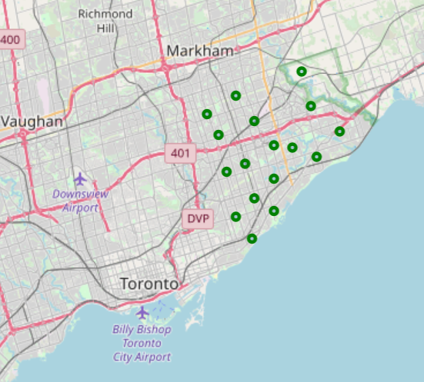

Observations and Discussions:

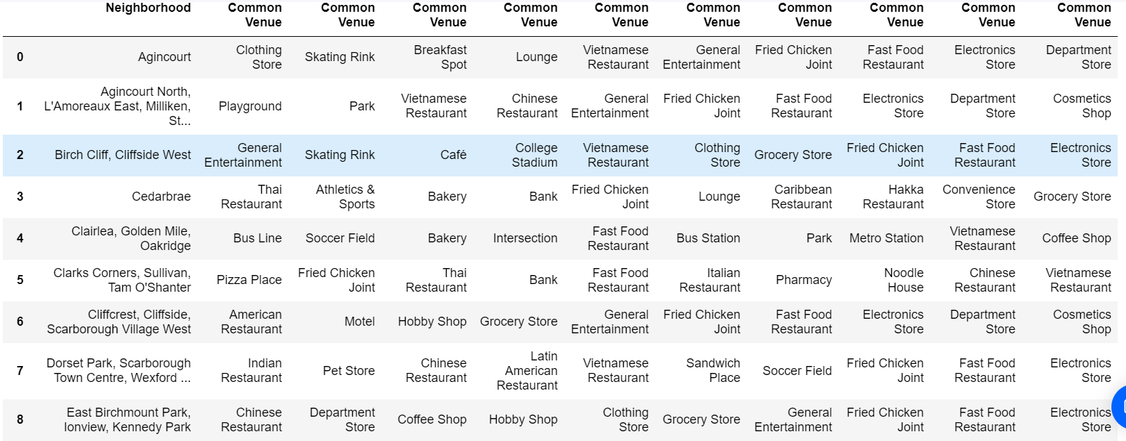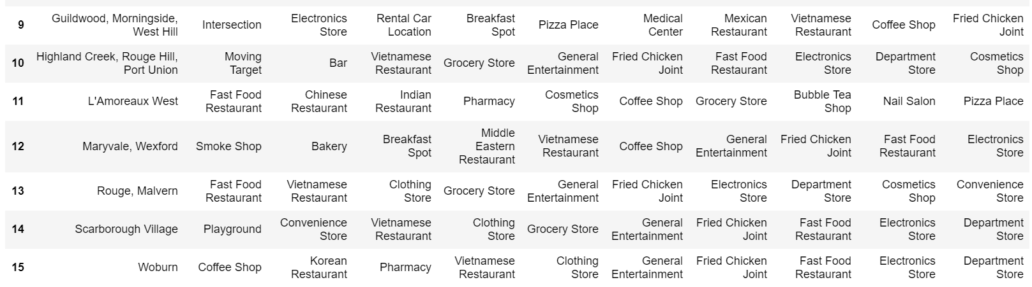

It is fairly obvious that western restaurants and Asian cuisines are most common (and likely to be popular) in all these neighborhoods. In addition, lite shopping spots and places to chill out are also welcomed in all the areas, indicating that these neighborhoods should be visitor-friendly and sportive.

Conclusion:

The neighborhoods of Scarborough are indeed of high cultural diversity and have well established public constructions that suit both visitors and residents for their needs. Tourists fond of outdoor activities, lite shopping, and Asian/American cuisines should be able to enjoy their trips to Scarborough.